Wolds Weighton Update for January 2021

1. Crime and ASB
Unfortunately due to technical changes we are unable to provide the monthly information at the moment. However you can obtain Crime and ASB data for your own area by visiting www.police.uk , clicking on “whats happening in your area” and entering your postcode.

2. Crime issues of particular note

The following list shows some of the crimes that have occurred in the previous month in your area.
- A secure campervan was stolen from a driveway of a property near Shiptonthorpe.
- A vehicle parked in a layby near Sancton was damaged, no entry was gained

3. Community Priorities
The Neighbourhood Policing Team meet regularly with partners to ensure we have a multi-agency approach to local issues, individuals and problem solving. These meetings are regularly attended by partners including Humberside Fire and Rescue Service, Youth and Family Support, Housing Officers, Environmental Health and the East Riding Anti-Social Behaviour Team. We share information and resources to deal with local neighbourhood issues, in particular, those identified as causing the most harm in the community.

High Visibility Patrols
We have been patrolling Market Weighton and the surrounding rural areas during our shifts. We are aware that there are many vulnerable people that live within the community and we want to reassure them that we are still here for you. We have also been posting on Social Media on a regular basis as a way of keeping everyone updated.

4. Crime Prevention Advice
COVID-19 Scams
Action Fraud has seen a number of different scams circulating relating to Covid-19. This includes people falling victim to online shopping scams, believing they are purchasing protective face masks or hand sanitiser that do not exist. Criminals are also using Government branding to make fake offers of financial support, making phone calls and sending unsolicited emails/texts that seem like genuine correspondence from HMRC, for example. A surge in phishing scams or calls claiming to be from government departments offering grants, tax rebates, or compensation is anticipated.
Criminals are looking to take advantage of people’s financial concerns as a result of the pandemic – they may ask for upfront fees applied to bogus loans, offer high-return investment scams, or commit fraud relating to pensions.
Huge increases in the number of people working remotely presents further opportunities for criminals to commit computer software service fraud. The increased demand on IT systems may make approaches of help to fix devices seem more believable, when in reality, criminals are trying to gain access to computers and/or login details.
Criminals are able to use spoofing technology to send texts and emails impersonating known and trusted organisations. We remind anyone who receives an unexpected text or email asking for personal or financial details to not click on the links or attachments, and to avoid responding to any messages that ask for personal or financial details.
Action Fraud provides useful advice on avoiding becoming a victim of online fraud or cybercrime. You can view their tips on their website, (www.actionfraud.police.uk) or make a report or get advice by calling 0300 123 2040.

5. News and appeals

- Humber Rural Policing Priorities - survey
On behalf of the East Riding of Yorkshire West Community Policing team, Insp Powell invites you to complete a short survey which is to be collated by the Office of the Police and Crime Commissioner. The survey is an opportunity for you to let us know what you think our rural policing priorities should be. The link below gives access to a survey where we are asking you to select your top 3 policing priorities specific to your area.

Please follow the link below and also share it to residents who live in rural areas of Humberside.

https://survey.alchemer.com/s3/6062468/Rural-Crime-Survey-2020

We look forward to hearing from you.

- Covid-19 Vaccine Text Scam Alert

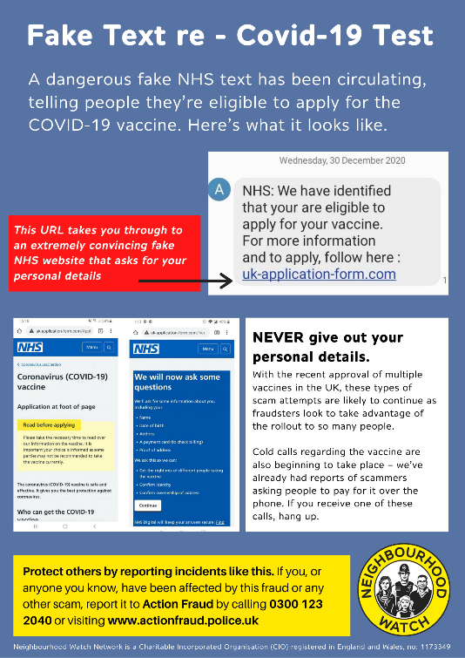
We have been alerted to a highly believable scam which starts with a text and advises the user that they are eligible to apply for the vaccine and to click on the link in the text message. The user is then led to a webpage, which looks very convincing and asks them to complete some details, in order for them to be able to apply for the vaccine.

The details asked for:
- Name
- Address
- Date of birth
- Proof of address
- Card payment details

With the recent approval of multiple vaccines in the UK, these types of scam attempts are likely to continue, as fraudsters continue to take advantage of the rollout to some many people.

Please click on the link below for further information:
https://www.ourwatch.org.uk/news/fake-text-identifying-you-eligible-covid-19-vaccine

- Guide to cyber security issued as fraudsters target farmers

Cyber attacks can be devastating for businesses and the individuals who are victims to fraudulent activity, it can affect agricultural businesses in a number of ways, including leaking of confidential data or financial losses. As farms rely more on technologies such as GPS, remote sensing and unmanned vehicles, the risks increase. Official statistics show a rise in reports of cyber attacks against the farming community, such as spoof farm machinery adverts that can leave farmers thousands of pounds out of pocket. For example, in 2019 more than 60% of agricultural businesses reported one or more attacks, compared with 45% in 2018, according to one cyber security company.

New guidance is being issued to farmers to help them protect themselves from cyber attacks such as spoof adverts, scam emails and malicious software. Put together by the NFU and the National Cyber Security Centre (NCSC), the online document aims to provide farmers with the tools they need to protect themselves from the most common cyber attacks.

Top tips for improved cyber security

- Ensure computers and mobile phones are set to install automatic updates
- Replace old hardware, which may be more vulnerable to attack
- Back up your data – perhaps on an external hard drive or USB stick or a cloud-based option
- Switch on password protection and use fingerprint or face ID on mobile devices
- Use things like tracking modes and remote data erasing modes on mobile devices
- Download anti-virus products to protect from “malware” (malicious software)
- Activate firewalls to create a buffer between your network and the internet

The new NFU/NCSC guidance identifies the main digital aspects that are at threat on farms, from the computers farmers use to send their emails and run their farm management software, to their automated machinery, security cameras and smartphones.

The guidance also offers advice on password creation, spotting and dealing with scam emails, texts and phone calls, and details of where to go for help. For further information please use the link below:

https://www.fwi.co.uk/news/crime/guide-to-cyber-security-issued-as-fraudsters-target-farmers

6. Surgeries
- Online Community catch up – Zoom Meetings
Insp Powell will be hosting a half-an-hour online community catch up via Zoom and he is inviting you to join him. There will also be the opportunity to ask any questions and raise any concerns/issues you may have. The next meeting for the Pocklington/Market Weighton & Villages will be held on the 15th February 2021 (14:00hrs)

For details on how to join the meeting, go to the Humberside Police website and type in ZOOM in the “search the site” section and this will take you to the “on line community catch up page” – click on this link for further information on how to join the meeting or click on the link below.
(https://www.humberside.police.uk/CommunityCatchUpNorthbank)

Stay informed through our social media channels, find us on Twitter, Facebook and Instagram:
https://www.humberside.police.uk/teams/wolds-weighton
Facebook – Humberside Police – East Riding of Yorkshire West
Twitter - Humberside Police – East Riding of Yorkshire West - @Humberbeat_ERYW
For incidents that don’t require an immediate response call our non-emergency 101 line. You can also report non-emergency crimes online via our reporting portal. In an emergency always dial 999.

