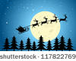
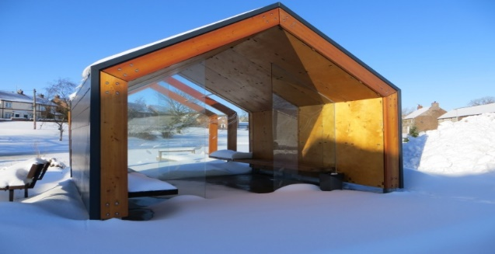

Arrangements are now being made for a
Christmas Gathering on
Saturday the 17th December

The format will be the same as previous years:
A Family Carol Service in the Church starting at 5:30 pm.
Then, if we sing loud enough, and he hears us,
Father Christmas
has said that he will make a special appearance on the green at about 6pm and bring presents for all the Fridaythorpe children who have been good this year.
There will be food and refreshments for children and adults alike.
If you would like to help out, we would encourage you to bring some festive food to share with your neighbours.

PS: The Event will go ahead given normal December weather so you may need wellies, thermals, waterproofs, etc – so please come prepared!
If the weather is REALLY bad the whole evening will be held in the Church.

PPS: To let us know who is coming please complete the form below and leave at the shop no later than Saturday 19th November so that Santa can do his shopping!!

--------------------------------------------------------------------------------------

Childs Name | Boy or Girl | Age

Number of Adults (16 or over):

